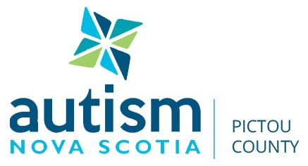

AUTISM NOVA SCOTIA – PICTOU COUNTY CHAPTER
Autism Spectrum Disorder is a lifelong neurodevelopmental disorder, usually diagnosed in childhood, which affects 1 in 68 people throughout the world. The condition appears to be more common among males. ASD can include any of the following:
- Intellectual Disabilities
- Communication Disorders
- Attention Deficit/Hyperactivity
- Learning Disorder
- Neurodevelopmental Disorders
- Social, Behavioural and Sensory Differences

The Pictou County Chapter of Autism Nova Scotia is a resource centre that guides individual/families to services which help manage and cope.
- Early Intervention
- Medical/Mental Health
- Education
- Recreation
- Programs
- Respite

The Centre also offers a variety of programs.
- Swimming
- Skating
- Art Therapy
- Music Therapy
- Yoga Therapy
- Challenger Baseball
- Summer Camp through Highland Community Residential Services
- Summer Camp and Activities at the Centre and throughout the Community
- Parent Support Group
- Chat N Chill Group for Adults with ASD

Each year the Chapter participates in “Walk the Walk for Autism”, which takes place at GR Saunders Elementary School in Stellarton. It is a family day with many activities along with a silent auction and includes a short walk, in which participants raise funds for the organization. There are also many business sponsors that contribute. This year the Chapter raised $70,000; these proceeds stay within Pictou County and benefit those with Autism.

The Resource Centre is located at 115 MacLean Street, New Glasgow – 902 695 5505
Monday 5-9; Tuesday, Wednesday, Thursday 9:30-1:30
autismpictoucounty.ca –-pictoucounty@autismns.ca –- https://www.facebook.com/AutismNSPictouCounty/

